**033/2 & 1 MOCK 2**

**June 2023**

**INTEGRATED**

**SCIENCE 2 & 1**

**Essay and Objective**

2 hours

**2&1**

Name: ………………………………………………………..

Index Number: ………………………………………………

**UNIVERSITY JUNIOR HIGH SCHOOL**

**UCC - CAPE COAST**

**MOCK TWO EXAMINATIONS**

June 2023 INTEGRATED SCIENCE 2 & 12 hours

Objective and essay

Do **not** open this booklet until you are told to do so. While you are waiting, read and observe the following instructions. Write your **name** and **index number** in **ink** in the spaces provided above.

This booklet consists of two papers. Answer Paper **2** which comes first, in your answer booklet and

Paper **1** on your Objective Test answer sheet. Paper **2** will last **1** hour 15 minutes after which the answer

booklet will be collected. Do **not** start Paper 1 until you are told to do so. Paper 1 will last 45 minutes.

*UJHS/mock 2 – 033/2&1-bm-aby/gmtl* **©2023 UNIVERSITY JHS**

DO NOT TURN OVER THIS PAGE UNTIL

YOU ARE TOLD TO DO SO.

***YOU WILL BE PENALIZED SEVERELY IF YOU***

***ARE FOUND LOOKING AT THE NEXT PAGE BEFORE YOU ARE TOLD TO DO SO***

PAPER I

June 2023  **INTEGRATED SCIENCE 1**  45 minutes

OBJECTIVE TEST

Answer all the questions on your Objective Test Answer Sheet.

**1.** Use 2B pencil throughout.

**2.** On the Objective Answer Sheet, write the following details all **correctly;**

Your **surname** followed by **other names**, Subject Name, Index Number, Centre Number and Paper Code.

**3.** In the boxes marked Candidate Number, Centre Number and Paper Code, shade each of the numbers correspondingly.

**4.** An example is given below. This is for a candidate whose name is Wilkins Nana **FRIMPONG.**

His index number is **0301078019** and he is writing the examination at Centre Number ***30109***.

**He** is offering **Integrated Science 1** and the Paper Code is **0331.**

**UNIVERSITY JUNIOR HIGH SCHOOL**

**UNIVERSITY OF CAPE COAST**

**OBJECTIVE ANSWER SHEET**

**CANDIDATE NAME:**

FRIMPONG WILKINS NANA

**SUBJECT:**

INTEGRATED SCIENCE 1

1. Use BB Pencil, Press firmly. your first mark completely.

2. Answer each question by choosing one 4. If only four alternative answers are given

letter and then, shade through the letter for each question, ignore the letter E.

chosen like this A B C D E 5. Your question paper may have fewer

3. If you want to change an answer, erase than 60 questions.

**3**

**0**

**1**

**0**

**9**

**CENTRE NUMBER**

**6**

**6**

**6**

**6**

**6**

**0**

**0**

**0**

**0**

**0**

**1**

**1**

**1**

**1**

**1**

**2**

**2**

**2**

**2**

**2**

**3**

**3**

**3**

**3**

**3**

**40**

**4**

**4**

**4**

**40**

**5**

**5**

**5**

**5**

**5**

**7**

**7**

**7**

**7**

**7**

**8**

**8**

**8**

**8**

**80**

**9**

**9**

**9**

**91**

**9**

**PAPER CODE**

**3**

**1**

**0**

**3**

**6**

**6**

**6**

**6**

**6**

**0**

**0**

**0**

**0**

**0**

**1**

**1**

**1**

**1**

**1**

**2**

**2**

**2**

**2**

**2**

**3**

**3**

**3**

**3**

**3**

**40**

**4**

**4**

**4**

**40**

**5**

**5**

**5**

**5**

**5**

**7**

**7**

**7**

**7**

**7**

**8**

**8**

**8**

**8**

**80**

**9**

**9**

**9**

**91**

**9**

**6**

**6**

**6**

**6**

**6**

**0**

**0**

**0**

**0**

**0**

**1**

**1**

**1**

**1**

**1**

**2**

**2**

**2**

**2**

**2**

**3**

**3**

**3**

**3**

**3**

**40**

**4**

**4**

**4**

**40**

**5**

**5**

**5**

**5**

**5**

**7**

**7**

**7**

**7**

**7**

**8**

**8**

**8**

**8**

**80**

**9**

**9**

**9**

**91**

**9**

**CANDIDATE NUMBER**

**0**

**3**

**0**

**1**

**0**

**71**

**8**

**0**

**1**

**9**



For

Supervisors

Only

If

candidate

is absent

shade

this

space

**0**

**0**

**0**

**0**

**1**

**1**

**1**

**1**

**2**

**2**

**2**

**2**

**3**

**3**

**3**

**3**

**4**

**4**

**4**

**4**

**6**

**6**

**6**

**6**

**7**

**7**

**7**

**7**

**5**

**5**

**5**

**5**

**8**

**8**

**8**

**8**

**9**

**9**

**9**

**9**

*UJHS/mock 2 – 033/2&1 bm-aby/gmtl* ©2023 UNIVERSITY JHS

SECTION A

[40 marks]

Answer **all** of Question **1**

1. (*a*) Study the hazard symbols below and carefully answer the questions that follow:

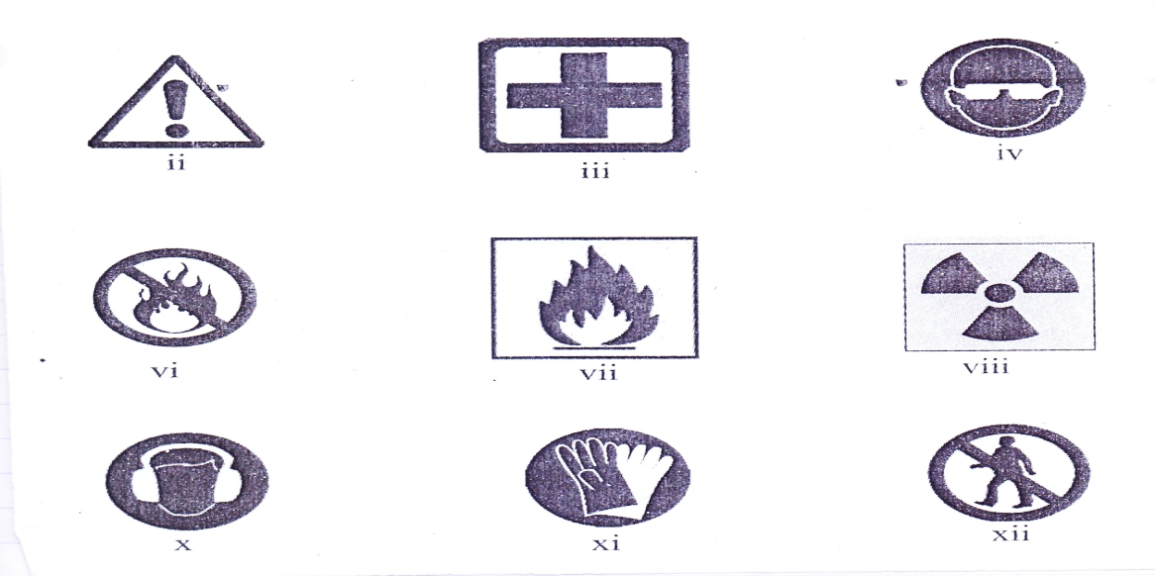

(i) What does each symbol represent?

(ii) Categorize the symbols under warning, mandatory, occasional safety signs and

prohibition safety signs.

(iii) Which of the safety signs can be found on chemical containers such as the petrol tanker?

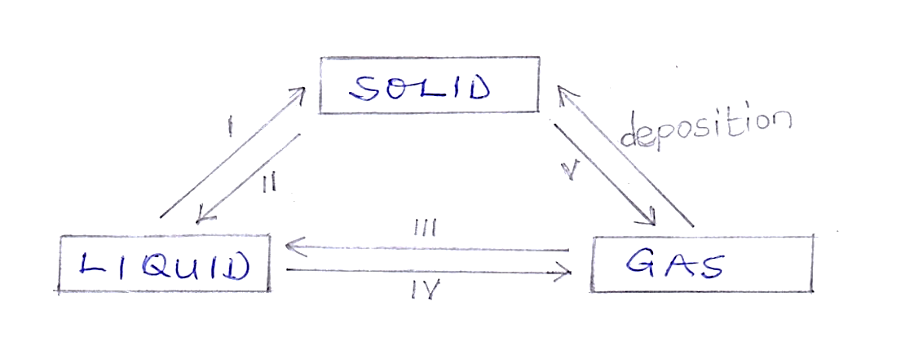(b) Study the diagram below and answer the questions that follow:

(i) Suggest an appropriate name for the illustration above.

(ii) Name the parts labelled **I, III, II, IV and V.**

(iii) Name two substances that can undergo **V**.

(iv) At what temperature will **I** take place?

(v) Mention any solid substances that can undergo **IV** when melted.

(c) The diagrams below show different types of vegetables grown in Ghana.

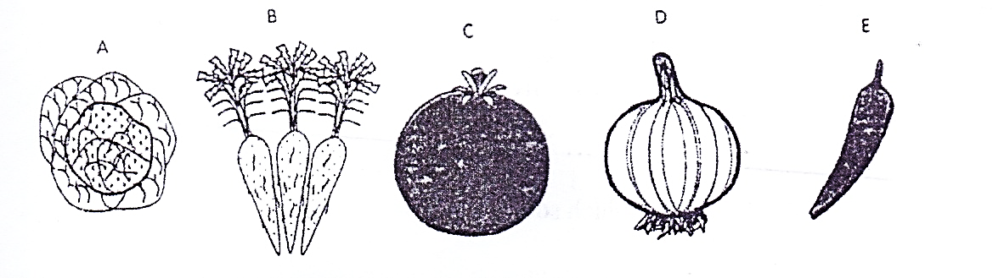Carefully study them and answer the questions that follow.

(i) Identify each of the vegetable crops labelled **A - E**.

(ii) Classify the vegetables according to their edible part(s).

(iii) Name **two** (2) of the vegetable crops that are nursed before planting.

(d) Use the ray diagram below to answer the questions that follows.

I

i

r

II

III

IV

V

Y

X

(i) State a suitable title for the ray diagram illustrated above.

(ii) Identify the parts labelled **I-V.**

(iii) Explain why r0 is not the same as i0 in the diagram.

(iv) State the **two** (2) effects of the phenomenon demonstrated.

**SECTION B**

[60 marks]

Answer **four** questions **only** from this section

**2.** (*a*) Briefly explain why atoms are electrically neutral.

(b) State **one** function of each of the following parts of a living cell.

(α). Nucleus

(β). Cell membrane

(ϒ) Chloroplast

(c) A child is found not to be able to see at night.

(i) What deficiency disease may the child be suffering from?

(ii) What food nutrient is the child lacking?

(iii) State **two** sources of food substances that can provide the nutrients that the child lacks.

(d) (i) Write the systematic name for each of the compounds below

(α). FeCl3 (β) Cu2O (ɣ) NH3 (€). SO2

(ii) Describe how scientists work.

**3**. (*a*) Briefly explain why non-reactive metals are preferred in making ornaments and jewellery

(b) (i) What is rusting?

(ii) State two effects of rusting?

(c) (i) Define the term pollination.

(ii) State orderly the first four stages in the life cycle of a flowering plant.

(d) (i) What is kinetic energy?

(ii) State the formula for calculating kinetic energy of a body.

(iii) Give any **two** (2) roles of capacitor in a circuit.

**4.** (*a*) (i) List the **three** particles which make up matter.

(ii) State one difference each between molecules in liquid state, solid state and gaseous

state. (Tabulate)

(b) State **four** areas of life where science and technology have brought improvement.

(c) (i) State **two** ways in which crop rotation is important in crop production.

(ii) List **three** characteristics of living things.

(d) Complete and balance each of the following chemical equations.

(i) Fe + O2 Fe2 O3

(ii) Al +Cl2 AlCl3

(iii) H2O + Li

**5.** (*a*) Name the instrument used in measuring the following

(i) Volume of a cement block

(ii) Volume of a liquid

(iii) Temperature of human body

(iv) Length of teacher’s table

(b) Calculate the area of a square length 9 m.

(c) (i) State **two** reasons why legumes are added in crop rotation. (ii) Define;

(α) mono cropping

(β) Mono culture

(d) What type of change will occur when,

(i) a piece of cooked yam is found in the stomach?

(ii) a piece of meat is found in the ileum?

(iii) a piece of pork fat is found in the stomach?

**6.** (a) Name **three** hazards that can occur in teaching and learning of science.

(b) List **two** safety precautions against hazards in teaching and learning of science.

(c) (i) What is seed germination?

(ii) List the **two** types of seed germination.

(d) (i) List any **four** conditions necessary for photosynthesis.

(ii) Explain the term forward bias.

***END OF ESSAY TEST***

Each question is followed by four options lettered **A** to **D**. find the **correct** option for **each** question and shade in **pencil** on your answer sheet the space which bears the same letter as the option you have chosen.

Give only **one** answer to **each** question.

Now answer the following questions.

1. An electrically charged particle formed when an atom gain or lose electron(s)

A. An electron

B. An ion

C. a molecule

D. proton

2. What is the volume of an object whose mass is 45kg and a density of 9kg/m3

A. 5 m3

B. 5 m-3

C. 54 m-3

D. 405 m3

3. The amount of force exerted by gravity on the object is known as

A. mass

B. volume

C. weight

D. work

4. For an object to float in a fluid, it must displace a quantity of the fluid equal to its….

A. mass

B. surface

C. volume

D. weight

5. Which of the following area of study is a natural science?

A. Medicine

B. Meteorology

C. Biology

D. Agriculture

6. The chemical symbol for iron is;

A. Fe

B. I

C. K

D. Pb

7. Choose the correct statement:

A. a proton is a negatively charged particle.

B. a proton is a positively charged particle.

C. the mass of a proton is not equal to that of a hydrogen atom.

D. the total number of protons and neutrons in an atom is its atomic number.

8. Which of the following is a non-metal?

A. Mg

B. P

C. Ca

D. Al

9. Which of the following describes a metal?

A. It accepts electrons

B. It becomes negatively charged in solution

C. It does not replace hydrogen from acids

D. It gives up electrons

10. Rigidity in plant cells is provided by the:

A. cytoplasm

B. cell membrane

C. cell wall

D. protoplasm

11. Find the volume of a cube sugar whose sides measures 8mm

A. 16 mm3

B. 64 mm3

C. 512 mm2

D. 512 mm3

12. A uniform mixture of two or more metals is called

A. a solution

B. a compound

C. a colloid

D. an alloy

13. The process by which a naphthalene ball placed in a box gets smaller in size is termed

A. evaporation

B. diffusion

C. sublimation

D. melting

14. Air is regarded as a mixture because….

A. it contains substances which can be separated by physical means

B. it contains elements which are chemically combined

C. it contains nitrogen and argon elements

D. can support burning

15. The part of cocoyam which is used in propagation is the

A. bulb

B. corm

C. seed

D. sucker

16. The part of the flower that produces pollen grain is the

A. anther

B. filament

C. petal

D. stamen

17. to test for sugar in urine, we use………

A. litmus paper

B. base

C. organic acid

D. plastic strip

18. The base of a triangle is 16cm and the height is 10 cm. Find the area of the triangle.

A. 320 cm2

B. 160 cm2

C. 26½ cm2

D. 80 cm2

19. Which of the following is the organic part of soil?

A. Humus

B. Mineral salt

C. Rock particles

D. Water

20. Which of the following environmental factors can cause the fastest rate of water loss from leaf surfaces?

A. Dry air

B. Low temperature

C. Still air

D. Wet wind

21. Which of the following activities does not cause soil erosion?

A. Bush burning

B. Clearing of vegetation

C. Crop rotation

D. Over-grazing

22. The charge of carbon in calcium carbonate is

A. +2

B. +3

C. +4

D. +5

23. Which compound will be formed when oxygen reacts with lithium in a chemical reaction?

A. li2O

B. liO

C. Oli

D. O2li

24. The part of a seed which grows to become the shoot of a plant is the

A. cotyledon

B. plumule

C. radical

D. testa

25. A fuse is used in an electrical circuit to

A. Make sure current flows continuously

B. Measure the energy used up

C. Protect appliances

D. Provide more appliances

26. Which of the following vegetable crops is cultivated for its leaves?

A. Carrot

B. Lettuce

C. Okro

D. Pepper

27. When a capacitor is connected in a series circuit with LED, a battery and a switch, the LED flashes and stays on because…..

A. Capacitor maintains power supply when device is unplugged.

B. Capacitor rectifies current fluctuation for signal

C. When capacitor is fully charged, it acts as open circuit.

D. Stores electric energy when they are corrected to a charging circuit.

28. Which of the following processes is a physical change?

A. Burning of wood

B. Formation of water from hydrogen and oxygen.

C. Rusting of iron

D. Solidification of water into ice

29. The vegetable crop that requires staking during its growth is….

A. Garden eggs

B. Hot pepper

C. Sweet potato

D. tomatoes

30. All the following are unicellular organism *except*……

A. amoeba

B. bacteria

C. semolina

D. virus

31. Which of the following is not part of the steps used by scientist in doing their work?

A. Hypothesis

B. Identifying problems

C. Observing

D. Technology

32. The major charge carries in the N-type semi-conductors are

A. cathode

B. holes

C. neutrons

D. protons

33. Flies, lice and ticks are all examples of

A. ecto-parasite

B. endo-parasite

C. insects

D. pests

34. The opposition to the flow of charge is measured in

A. Ampere

B. Ohms

C. Volt

D. Watt

35. Which of the following crops is planted at stake?

A. Cabbage

B. Carrot

C. Garden egg

D. Sweet pepper

36. What is the colour code of a neutral wire?

A. Brown

B. Blue

C. Green

D. Yellow

37. A pure substance formed from the chemical combination of two or more elements is….

A. atom

B. compound

C. element

D. molecule

38. Which of the following compounds is neutral to litmus paper?

A. Hc*l*

B. H2O

C. NaOH

D. KOH

39. In an electronic circuit, LEDs are used to indicate the absence or presence of;

A. Electric current

B. Emitter and collector

C. P-njunction

D. Voltage source

40. A food web shows how

A. an organism protects itself in its environment

B. food produced by plants is distributed to other parts of the plant

C. food produced by green plants is distributed among organisms in a community.

D. organisms depend on one another for shelter.

***END OF PAPER***